11/17/2017
NCT Analysis
Functional specification
Allen Higgins C00197373,
Zoltan Fuzesi C00197361,
Robert Scully C00196960
ITCarlow

Table Of Contents
Objectives 2
Overview 2
Phase 1 3
Phase 2 3
Phase 3 3
Phase 4 3
Architecture 4
API 4
What is REST? 4
Hadoop 7
Project layout 9
Functionality 12
Functionality description. 13
User Interface description. 19
External Interfaces. 20
Potential Risks/Issus 20
Dataset 20
Transformation 21
Code 21
API 21
Database 22
Hadoop 22
Output 22
Gantt chart and time line for project 23
Bibliography 24
Objectives

Overview

The main Objective of the project is to analyse data from the Road Safety Authority in relation to the national car test, and predict the most consistently reliable car to purchase in the used car sales market. As to, it is the intention to prove what might be previously thought of as the most reliable car to claim ownership of such as Toyota, where it could be common knowledge to assume that such a model is consistent in performance though not backed with supporting data. The finding results may prove what is believed to the common knowledge and assure a prediction into the future of a strong growing trend. Indeed, the result may also prove that other makes and models thought uncommon in constant reliability, or not considered at all, may prove contrary to belief. In any case it is hope that the project will be of value to the car sales industry when determining which type of preowned car to stock, or indeed, to the public consumer when deciding which type of car they would like to purchase as a suitable investment.

To achieve the project’s main objective, it is anticipated that sub objectives could be introduced when implementing the use of technology to aid with analysing the data. From a technology point of view one clear sub objective is to not only obtain the relevant data but also the clean and store the data for use in a suitable data model. National Car Test data comes in the form of either PFD’s of Excel spread sheets. For PFD’s it is the intention to create python scripts that will parse the data by row and column and writing the parsed data to a CSV file which would be more easier to use at a later stage. Cleaning the data is essential. Determining that fields are not left empty, if so how many and to what effect that will have on the data model. As to, understanding the data. Do column headings in deferent files mean the same? Do their values represent the same meaning? Is the data from file to file reliable? If the data is verified and cleaned it could be stored more meaningful in a database where some field could be combined, others left out due to not been required by the scope of the project and meta data added to describe the data more accurately for future analytics as a result of this project.

The data, when cleaned, is intended to be consumed by a Java API which should intern allow for an entry point to a server that will begin to store the data in a specifically designed tabular database. The objective here is to allow use of data for the model as and when needed. This should allow for experimenting with different types of data models as some may not require all information about a particular car where as others may. As to, searches for individual types could be carried out in accordance to particular algorithms such as only enquiring if a car were of a certain age and passed on the first attempted. Ultimately, the objective at this point is to allow the project full control over how the data could be used either as of the current time or with regard to future projects.

Once the data has been store to a satisfactory standard and has proven to be reliable and is clearly understood, the objective at this point is to create a small cluster with consumer grade computers with the use of Apache Hadoop. The main computer will act as the master will other computers added to the cluster will behave as selves, dividing up the work between them, the result of which should then be passed back to the master. Map reduce should divide the data-set into independent groups that can be processed in parallel allowing for quicker processing of data on a large scale. To create connection between the Master and salve devices a shared network connection needs to be established. To achieve a strong performance, the use of a hard-line with a connecting network switch is preferable. One option is to use a Linksys router to establish the local network. The introduction of Hadoop allows the project to scale if needed and also introduces an element of learning and experience in relation to data science storage and mining. In other words, one objective is to understand and produce on a small scale the idea of a data warehouse or data lake, store and consume the data.

Objectively, the project proposes different phases to aid in delivering the overall result and analytic findings. Below is the intended outline sectioned into four different stages with clear objectives for each phase as referred to in the Project Specifications document under Deliverables.

Phase 1
The Objectives during this phase include a python script for data mining to read and create a dataset from PDF to CSV file format. From this it is intended to create a RESTful API to connect to the database to store and retrieve data. It is envisioned that the data will be stored in a MySQL database as the data obtained from the CSV files best suit a tabular format at this time. Ultimately, this allows for retrieving cleaned data from an API while passing it to the Apache Hadoop framework to create a distributed process between a consumer grade network of computers to process and analyse the data. Map Reducer should divide the data to independent tasks to process in a parallel manner, increasing the speed of the process as a data grows on a larger scale. This objective is intended to also add a learning experience to the project as mentioned earlier.

Phase 2
The Objectives during this phase include creating a prototype of the web API with Java and prove out the potential use it will have in relation to connecting to the database and carry out basic/advanced stream between API and database. Create the Python modules for use in parsing the PDF files into comma separated files (CSV). Using the CSV files, it is then hoped to read and store the data to the database. In doing so it is anticipated that the project should identify potential risks in the API communication and Python module implementation.

Phase 3
The Objectives during this phase include a successful ccommunication link between all interfaces. Read, write and save data-sets with Python, Java and MySQL. Also, identify network computers compatible with Apache Hadoop.

Phase 4
Connect to the consumer grade cluster of computers with Apache Hadoop framework and carry out different data analysis on the input data-set using Python modules. It is hoped to display the result using visual chart, graph, histogram or scatter plots appropriate to the results.

The end of the project a final report should be produce documenting the project’s process, results, findings and projections. This includes analysis of the project’s success, or if unsuccessful, a full detailed description and understanding as to why the project was unsuccessful. It is also an opportunity to document any learning outcomes over the duration of the project’s lifetime which may be of use to future project works in this area.

Architecture
Architecture application in software is a structured solution, that defines any technical and operational requirements within that project. The requirement needs to optimize the common quality of its attributes, for example performance, security, and manageability. The decision made here can impact the quality, performance, maintainability, and overall success of the application.
Philippe Kruchten, Grady Booch, Kurt Bittner, and Rich Reitman derived and refined a definition of architecture based on work by Mary Shaw and David Garlan (Shaw and Garlan 1996). Their definition is:
“Software architecture encompasses the set of significant decisions about the organization of a software system including the selection of the structural elements and their interfaces by which the system is composed; behaviour as specified in collaboration among those elements; composition of these structural and behavioural elements into larger subsystems; and an architectural style that guides this organization. Software architecture also involves functionality, usability, resilience, performance, reuse, comprehensibility, economic and technology constraints, trade-offs and aesthetic concerns.”

API

It is imperative that modern Web applications provide desktop-like rich browser interfaces using Asynchronous JavaScript and XML (Ajax) or the Google Web Toolkit (GWT) as well as RESTful Web services to external client applications.

What is REST?

REST, or REpresentational State Transfer, is an architectural style for providing standards between computer systems on the web, making it easier for systems to communicate with each other. REST-compliant systems, often called RESTful systems, are characterized by how they are stateless and separate the concerns of client and server. We will go into what these terms mean and why they are beneficial characteristics for services on the Web.
Guiding Principles of REST
- Client–server – By separating the user interface concerns from the data storage concerns, we improve the portability of the user interface across multiple platforms and improve scalability by simplifying the server components.
- Stateless – Each request from client to server must contain all of the information necessary to understand the request, and cannot take advantage of any stored context on the server. Session state is therefore kept entirely on the client.
- Cacheable – Cache constraints require that the data within a response to a request be implicitly or explicitly labelled as cacheable or non-cacheable. If a response is cacheable, then a client cache is given the right to reuse that response data for later, equivalent requests.
- Uniform interface – By applying the software engineering principle of generality to the component interface, the overall system architecture is simplified and the visibility of interactions is improved. In order to obtain a uniform interface, multiple architectural constraints are needed to guide the behaviour of components. REST is defined by four interface constraints: identification of resources; manipulation of resources through representations; self-descriptive messages; and, hypermedia as the engine of application state.
- Layered system – The layered system style allows an architecture to be composed of hierarchical layers by constraining component behaviour such that each component cannot “see” beyond the immediate layer with which they are interacting.
- Code on demand (optional) – REST allows client functionality to be extended by downloading and executing code in the form of applets or scripts. This simplifies clients by reducing the number of features required to be pre-implemented.
On the server side, the application state and functionality are divided into resources. A resource is an item of interest, a conceptual identity that is exposed to the clients. Example resources include application objects, database records, algorithms, and so on. Every resource is uniquely addressable using a URI (Universal Resource Identifier). All resources share a uniform interface for the transfer of state between client and server. Standard HTTP methods such as GET, PUT, POST, and DELETE are used. Hypermedia is the engine of the application state, and resource representations are interconnected by hyperlinks.
Another important REST principle is the layered system, which means a component cannot see beyond the immediate layer with which it is interacting. By restricting knowledge of the system to a single layer, a boundary is placed on the overall system complexity, promoting substrate independence.
REST architectural constraints, when applied as a whole, generate an application that scales well to a large number of clients. It also reduces interaction latency between clients and servers. The uniform interface simplifies the overall system architecture and improves the visibility of the interactions between subsystems. REST simplifies implementation for both the client and server.
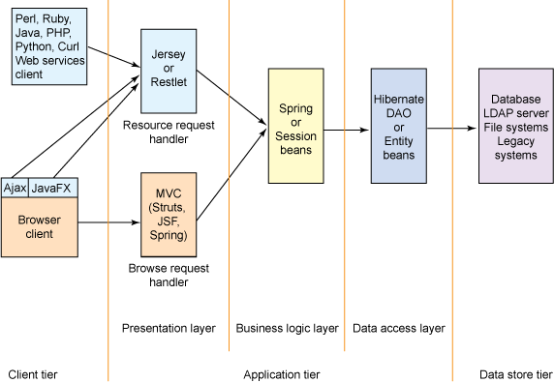
Figure 1. Diagram of a multi-tiered Web application

Hadoop

Hadoop is an open source software built by Apache. The software is a framework for storage and large-scale processing, it does this on large data-set, by clustering the data on commodity hardware. There are mainly five building blocks inside this runtime environment (from bottom to top):
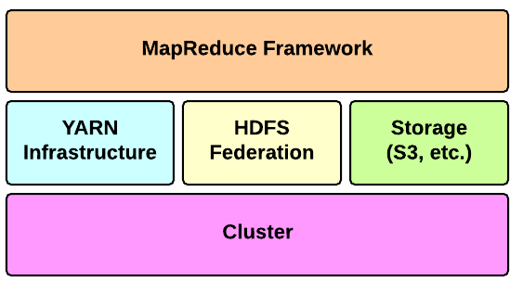
Figure 2: Hadoop Runtime Environment

Apache Hadoop offers a scalable, flexible and reliable distributed computing big data framework for a cluster of systems with storage capacity and local computing power by leveraging commodity hardware. Hadoop follows a Master Slave architecture for the transformation and analysis of large datasets using Hadoop MapReduce paradigm. The 3 important Hadoop components that play a vital role in the Hadoop architecture are -
- Hadoop Distributed File System (HDFS) – Patterned after the UNIX file system
- Hadoop MapReduce
- Yet Another Resource Negotiator (YARN)
Hadoop follows a master slave architecture design for data storage and distributed data processing using HDFS and MapReduce respectively. The master node for data storage is Hadoop HDFS is the NameNode and the master node for parallel processing of data using Hadoop MapReduce is the Job Tracker. The slave nodes in the Hadoop architecture are the other machines in the Hadoop cluster which store data and perform complex computations. Every slave node has a Task Tracker daemon and a DataNode that synchronizes the processes with the Job Tracker and NameNode respectively. In Hadoop architectural implementation the master or slave systems can be setup in the cloud or on premise.

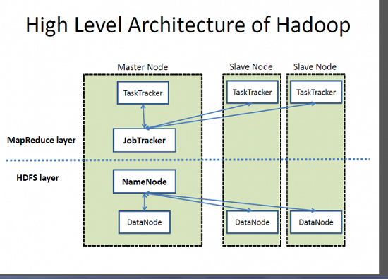
Figure 3: High level Architecture of Hadoop
The heart of the distributed computation platform Hadoop is its java-based programming paradigm Hadoop MapReduce. Map or Reduce is a special type of directed acyclic graph that can be applied to a wide range of business use cases. Map function transforms the piece of data into key-value pairs and then the keys are sorted where a reduce function is applied to merge the values based on the key into a single output.

Project layout

For the current project, the Hadoop structure will consist of three nodes, one will be set as the master, while the order two will be the slave. Figure 4 will show the basic layout:

Master
slave
slave

Figure 4: Current layout of Hadoop Structure.
There may be a fourth node add later in the project, to improve productive, speed and time to do the task.

Databases
A Database is a collection of records. Database management systems are designed as the means of managing all the records. Database Management is a software system that uses a standard method and running queries with some of them designed for the oversight and proper control of databases.
There are many different types of databases in use these days, the following is a few examples of these different types:
- Relational Databases
- Document-Oriented Database
- Real-Time Database
- Hypermedia Database
There are a lot more, but for this project, the type of database that will be used is Document-Oriented Database. There are also many different versions of this type of database, for this project the version called MariaDB will be used.
MariaDB Column Store is a columnar storage engine designed for distributed massively parallel processing (MPP). It consists of a number of different components, working together.

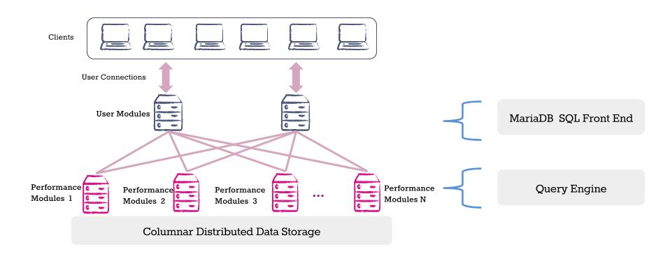
Figure 5: Columnar Distributed Data Storage.
These components include:
- User Module:
The User Module is made up of the front end MariaDB Server instance and a number of processes specific to MariaDB Column Store that handle concurrency scaling. The storage engine plugin for MariaDB Column Store hands over the query to one of these processes which then further break down SQL requests, distributing the various parts to one or more Performance Modules to process the query. Finally, the User Module assembles all the query results from the various participating Performance Modules to form the complete query result set that is returned to the user.
- Performance Module:
The Performance Module is responsible for storing, retrieving, and managing data, processing block requests for query operations, and passing it back to the User Module(s) to finalize the query requests. The Performance Module selects data from disk and caches it in a shared nothing data cache that is part of the server on which the Performance Module resides. MPP is accomplished by allowing the user to configure as many Performance Modules as they would like; each additional Performance Module adds more cache to the overall database as well as more processing power.
- Storage:
MariaDB Column Store is extremely flexible with respect to the storage system. When running on premise, it can use either local storage or shared storage (e.g. SAN) to store data. In the Amazon EC2 environment, it can use ephemeral or Elastic Block Store (EBS) volumes. When data redundancy is required for a shared-nothing deployment, it is built to integrate with GlusterFS and the Apache Hadoop Distributed File System (HDFS). In the first alpha release only local storage, shared storage and EBS configuration have been tested. HDFS and GlusterFS testing will be done in future alpha releases.

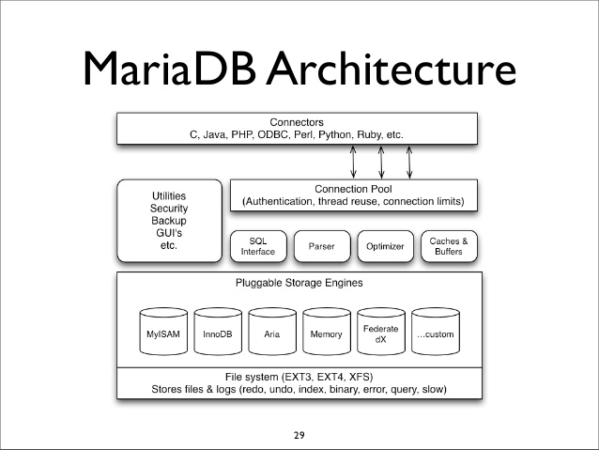
Figure 6: MariaDB Architecture.

Functionality

The NCT data science project includes many internal and external modules to achieve the required computations like reading the one-star data, store, select, retrieve, distribute and display the results in many different charts. The charts will be the visual representation of the stated questions like:
- Which is the best reliable car model that most likely will pass the NCT test.
- Which is the worst car model that possibly will fail on the NCT test.
- Which car make, or make and model is the best future investment to suggest to the customers.
- What is the most likely problem with the given car model on the NCT test?
- And many possible questions and outputs.
The flexibility of the NCT project is that there are no limitations on the stated questions, because the product use SQL database to store tabular data, and can retrieve any variant of the data by the SQL queries. The following diagram is the visual representation of the final product connected the internal and external components/interfaces.
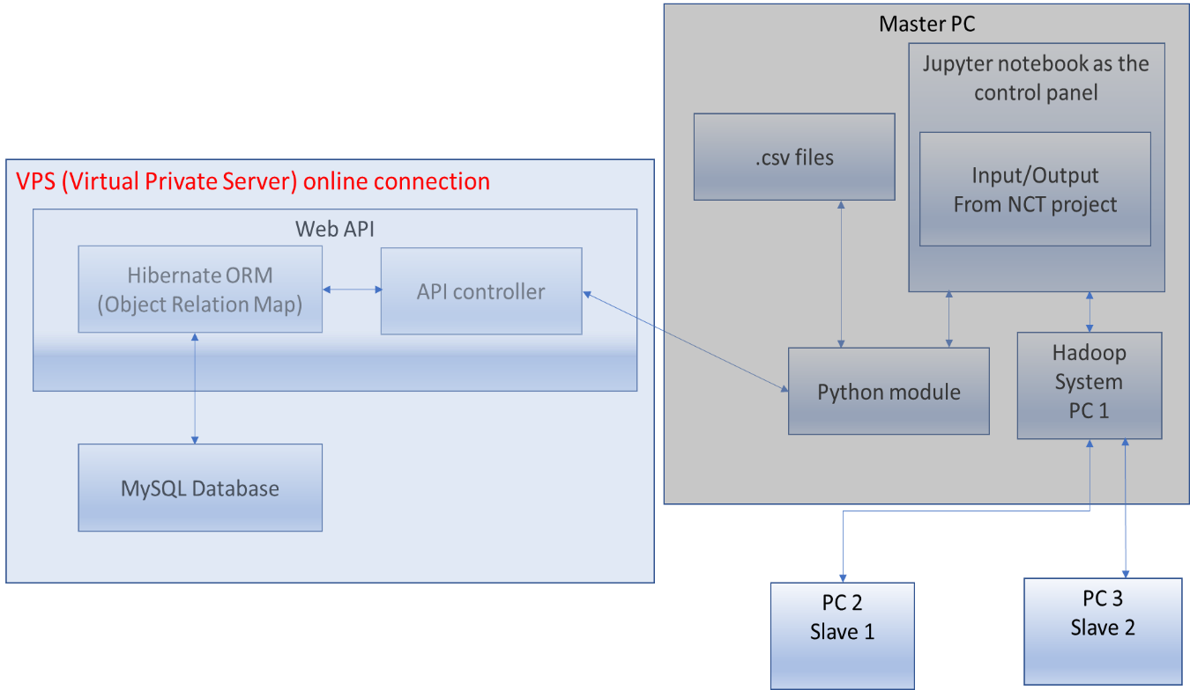
Figure 7: NCT data science project system representation.

The main scenario of the system functionality should happen in sequences. First the user must access the main module to operate the product, what will be IPython Jupyter kernel module. This interface can access the Python code, to carry out function calls, to connect the internal and external parts to work together as a single unit. The user should be able to read tabular files from the operating system and send the row values to the database. Able to send SQL queries to the web API to retrieve selected rows and column to calculate and display charts. To distribute the processing jobs between network connected computer, in the project the Hadoop system will be used. The charts will be displayed with the IPython Jupyter kernel in the web browser.

Functionality description.

The NCT project will use IPython Jupyter notebook through the web browser as a main user interface to interact and operate the product. The Jupyter notebook can connect to the Python files and able to execute the functions within the files.
After the Jupyter notebook started, the user will need to start a new kernel in the notebook, to use the built-in command line. In the command line must to import the modules to intend to use in the process.
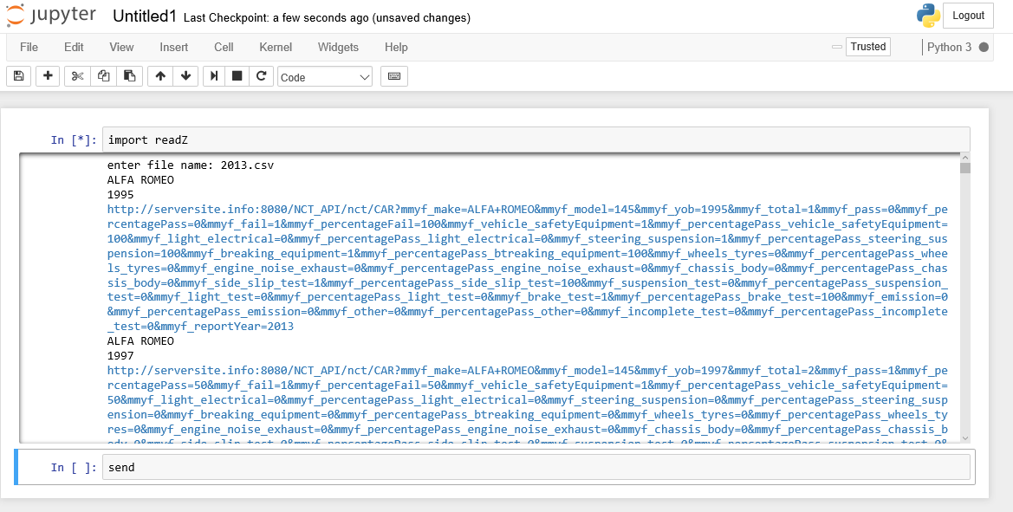
Figure 8: Jupyter Main page.
As the picture shows above the “send” method called by the IPython Jupyter notebook, and the python scripts start reading the 2013.csv file line by line. In the same time, it is building up the URL call requests and executes it and sending to the web API. In this way the project can be controlled by the Jupyter kernel, such as reading the NCT related csv files, sending to the web API, receiving a HTML status code or a specific respond from the API.
The API built in Java Spring MVC (Model View Controller) design pattern, with transactional data access objects (DAO), that are mapped with Hibernate ORM (Object Relation Mapping) technology. In this way the web API make sure there is no partial transactions can happen, because if any part of the registering process fails, then the database access will not happen and refuse the transaction. In this way the Python module can keep track of any single API call happen, or fail. When the API call fail the module should try to repeat the row injection to the database as it is resending the values. The API implements few listeners’ methods in the controller. The first method responsible to listen for the API calls to save the sent values of car make and model details. The other method listens for NCT test centres result. Bought method is connected to the corresponding mapped data access object and save the details to the database. To operate the NCT project through the web interface, the API must implement at least one method in the controller to listen for the SQL requests from the Python modules, and sends back the collected data from the database in JSON format. To make selection of the database, this method will be responsible to break down the request and build the equivalent Hibernate ORM database calls.
The Hibernate ORM mentioned above is the key to the database mapping process. It is framework to mapping object oriented model to a relation database. So, it is very tight programmed to the data set, since every single column value want to save in the database, must implemented in the Java model. The model attributes name, database table, column names must match. The project use two different model, one for the make and model mapping, and the another to the NCT test centres model mapping. This technology can create a database table if the database exists, but the table in the database not exist.
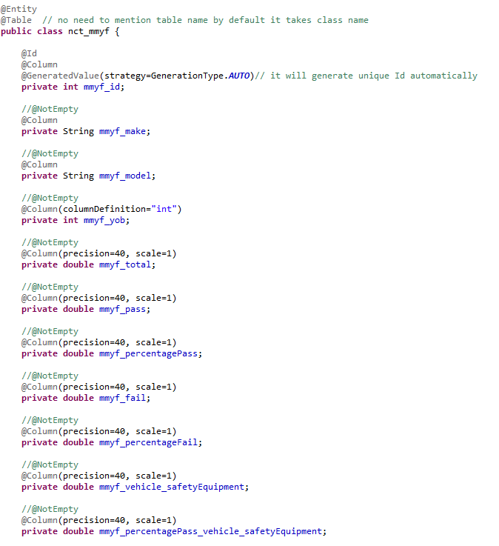
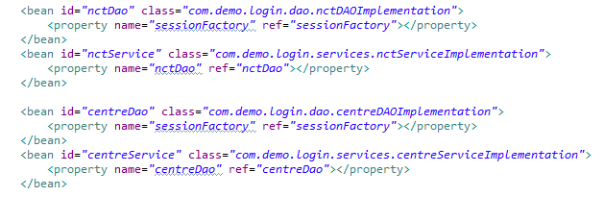
Figure 9: Java code for Hibernate ORM

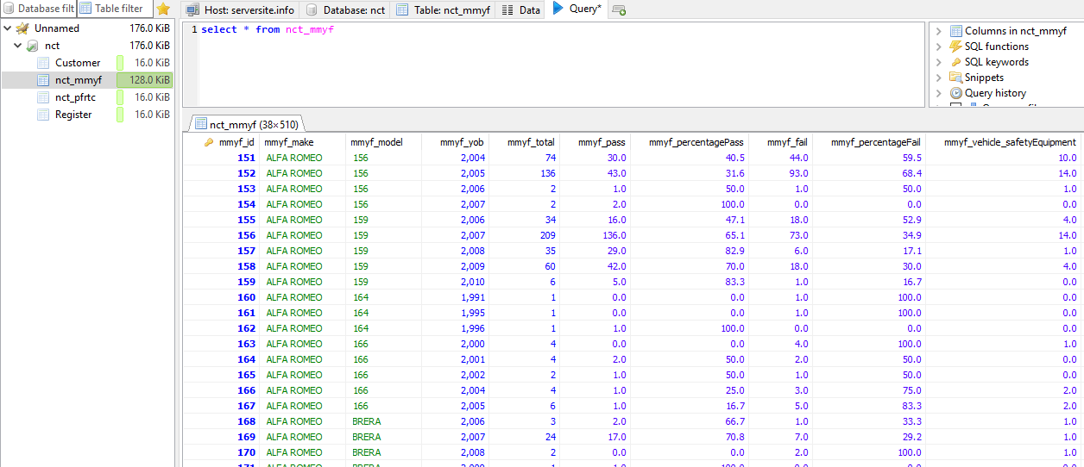
Figure 10: Database Query page.
As the part of the system, need to mention the application server that runs the Spring MVC web API. It can be important since the Java API does not use direct database connection, it is connected to the application server connection pool. The application server is a Payara (Glassfish) J2EE container with a direct connection pool to the MySQL database, that can handle the communication between the Java API and the database itself. The default pool size is 8 to 32 connections, that can be extended if the requests cannot be executed in fast manner.
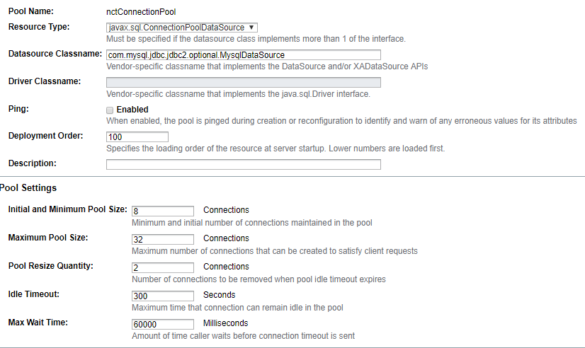
Figure 11: Application server connection pool settings
So, the API when receive the request from the Python module with a SQL queries, then it will be delegated to the Hibernate Object Mapping framework. The ORM is connected to the application server, and through it is connection pool sends the request to the database. When the selected respond arrives to the Hibernate ROM, the it is returning the result to the API. The API turn the result data set to JSON file and sends back to the Python module.
At this stage of the process the system saved the data set to the database, received the SQL requests from Python module and returned the result data set in JSON format. The Python stores all the data received from the API and starts communicating with the Hadoop file system.
As it was mentioned before, the NCT project will use Hadoop framework to distribute stored data and work process between network connected computers. Hadoop is a great environment for data transformation, but as a data science environment it poses challenges. The system use Map reduce technology that splits the data set into independent chunks which are processed by the map task in a parallel manner between the computers in the Hadoop networked system. Then the framework sorts the outputs of the maps, which are then input to the reduce tasks. The input and output of the job are stored in the file system. The Hadoop framework takes care of scheduling, monitoring and re-executes the failed tasks. (Hadoop, 2013) When Hadoop finish with the process of the data set, then return the processed value to the program function that requested the distributed data process.

In this point need to mention the usage of the Hadoop framework with Python programming language. Python has several interfaces to use the HDFS (Hadoop File System). The NCT project probably will use one of the following two libraries. (McKinney, 2017)

hdfs3 - is a lightweight Python wrapper for libhdfs3, a native C/C++ library to interact with the Hadoop File System (HDFS).
- PyArrow - Apache Arrow is an in-memory transport layer for data that is being read or written with Parquet files. PyArrow includes Python bindings to this code, (pyarrow, 2017)

Usage of hdfs3:
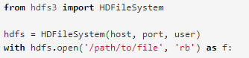
Usage of pyarrow:
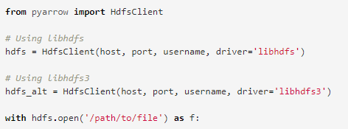
As a last step in the process, the Jupyter notebook should represent the processed data by the Hadoop and the python modules in a visual representative format. To achieve tis functionality with Jupiter must use some sort of Python library that can display data in charts. As one example of Python library to display result sets in chart, can use the Ploty’s python API. (ploty, 2015)
Usage of Ploty’s API:
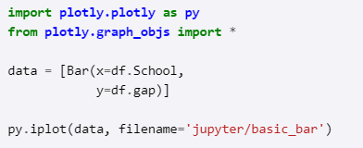

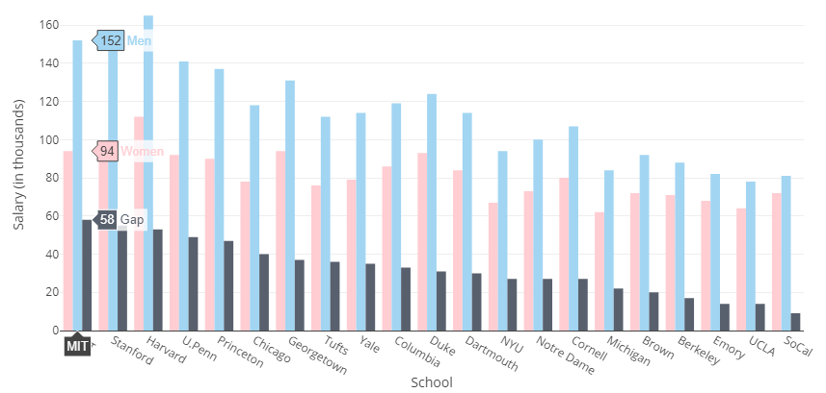
Figure 12: Chart example with ploty’s API.

User Interface description.

The user interface, that allows to interact with the NCT project, is an open-source application that allows to create and share documents that contains live code, equations, visualization and it is called Jupyter notebook.
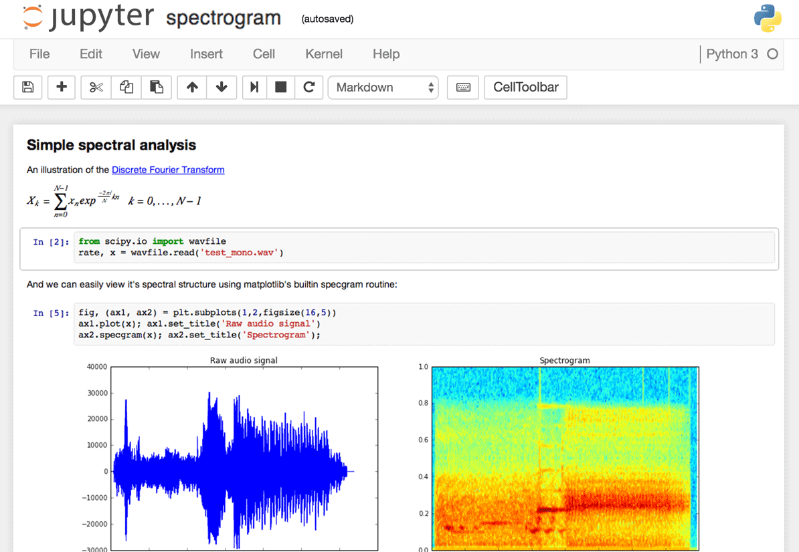
Figure 13: Jupyter Sample.
Jupyter notebook, known as the IPython notebook, is a flexible tool that can create analyses, can keep code, images, comments and plots together. Jupyter is very flexible and extensible, supports many programming languages and easy to install and start on a computer on a server.
To display tables, charts or any kind of visual representation, simply need to import a library and use the library interface to play around with the data and display it. The most important feature in Jupyter is the plotting features. There are many libraries are available to creating visual representation.
So, Jupyter is a good choice to use as the user interface in the project, since easy to install, support many libraries to create visual representation of digital data, and able to interact with external modules such as python or Hadoop system.
Few option to use in the NCT project for visualization of processed data:
- Matplotlib - (the de-facto standard)
- Seaborn - is built over Matplotlib and makes building more attractive plots easier
- Mpld3 - alternative renderer (using d3) for matplotlib code
- Bokeh - building interactive plots
- Plot.ly - generate nice plots
- Altair - new declarative visualization library

External Interfaces.

The one of the most important/complex and the less noticed external interface is the Virtual Private Server(VPS). It stores the database, keep up running the web API and the J2EE application server. Complex, because it needs to set up by the terminal, it must be secured and should be fast enough the network connectivity to serve the NCT data science project, when the big data sets will be send and stored in the database.
The other external interfaces are the networked slave computers, connected to the master computer in the Hadoop distributed file system to support the computation process. The computers need to be set up as well, but then they are waiting to the master computer instructions.

Potential Risks/Issus

As with any project there is always the growing potential risks that the main objectives may not always go according to plan. Issus may arise when previously unforeseen or unusual behaviours with expected results, technologies and understanding of the business needs conflict with the projects end result. As too, when working with data it can be inconsistent, uncomplete or misinterpreted in some way. Models may not suit the data which could lead to rethinking the model and investigation different approaches that maybe more suitable for the data. The following in relation to this project could be considered as potential risk or issues that arise throughout the course of the project.

Dataset

Dataset may not be detailed enough. It may be poorly constructed and lacking in quality such as one-star data. If the rows and columns from different sources suggest different meaning, this can conflict to the understanding of the data overall and derive to reconstruct the dataset. Ultimately, if the dataset is lacking in detail, misinterpreted or broken in structure then the project’s objectives; to prove with car is consistently most reliable and to predict such a trend into the near future for customer purchase of pre-owned cars, will not succeed.

Transformation

The Road Safety Authority supplies one and two-star data (W3C Standards) in relation to the National Car Test. A one-star data set includes PDF. This requires extra prepossessing to extract the data to covert to tabular format which may prove difficult and not be fit for purpose when complete.
For example, the first dataset examined in this project was a one-star data set. Using a Python script, the data could be easily parsed into CSV format. This may seem as though the data was extracted successfully, however, the data structure became broken and useful leading to a redesign of the data extraction process.
Two-star data comes in the form of XLS (excel spread sheet) which is tabular in format, more easier to use however still requires extraction for data analysis and if obtained from multiple sources field names and relationships may not be coherent or understood correctly.

Code

Code may be not efficient and algorithm computation time could lack in performance. Communication between to different languages such as Python and Java may encounter difficulties or incompatibility when working together. Each language has its own set of standards and implementation, core libraries, syntax and performance capabilities. Choosing the right technologies may sometimes prove challenging and issues arising may not present themselves until much later in the development life cycle of the project. At such a time the project deliverables could be set back in order to reproach or refactor the code and choices of technologies previously thought appropriate.

API

The Java API may not be able to handle large volumes of data requests in a short period of time as the Python models is capable of producing it. If this is an issue the threaded connection pool could be increased to allow a greater size of request at the same time. A public API could be subjected to script injection causing harm to the database or placing invalid and unreliable data into the datasets. For this reason one approach is to use an API key to restrict the API accessibility to authorised usability insuring that valid and only approved data can be added to the exciting dataset.

Database

Database injection attacks such as MySQL could potentially enable an attacker to execute malicious SQL statements. This could lead to attackers controlling the web API and database server by deleting or changing its behaviour. Unmanaged sensitive data could be exposed to threats if the user authentication permissions are not secure enough. This means if different databases on the server have no unique user and there are using the root admin user account, all databases would be available to exploitation especially if the root admin account has be compromised. This can be avoided by simple assigning a unique user for each database on the server so if one where compromised then not all would necessarily be compromised.

Hadoop

Hadoop cannot maintain reliable, predictable performance for scheduling jobs/queries if the network is overloaded. If there is a slowdown it takes too long to troubleshoot the issue and find the root cause (Xplenty, 2017).

Output

If the logic in the Python models are not correct then the results of the data would be incorrectly represented. This can lead to a misrepresentation of results thought previously to be conclusively correct. Ultimately, the findings of the project would mislead the prediction aspect of the over goals and aims project as set out in the objectives of this document.

Gantt chart and time line for project

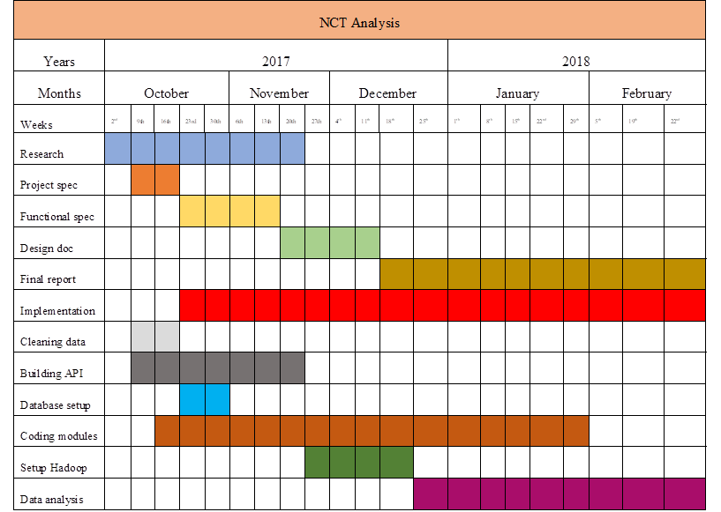

Bibliography

Devlin, J., 2016. 28 Jupyter Notebook tips, tricks and shortcuts. [Online]
Available at: https://www.dataquest.io/blog/jupyter-notebook-tips-tricks-shortcuts/
[Accessed 12 11 2017].
Hadoop, 2013. Hadoop. [Online]
Available at: https://hadoop.apache.org/docs/r1.2.1/mapred_tutorial.html
[Accessed 12 11 2017].
McKinney, W., 2017. Native Hadoop file system (HDFS) connectivity in Python. [Online]
Available at: http://wesmckinney.com/blog/python-hdfs-interfaces/
[Accessed 12 11 2017].
ploty, 2015. Jupyter Notebook Tutorial in Python. [Online]
Available at: https://plot.ly/python/ipython-notebook-tutorial/
[Accessed 12 11 2017].
pyarrow, 2017. Reading and Writing the Apache Parquet Format. [Online]
Available at: https://arrow.apache.org/docs/python/parquet.html
[Accessed 12 11 2017].
Xplenty, I. (2017, 11 16). Mitigating 5 Performance Risks of Managing Hadoop as a Shared Service. Retrieved from Driven: http://www.driven.io/2015/10/mitigating-5-performance-risks-hadoop-shared-service/
Google Images. 2017. Available at: https://images.google.com/
[Accessed: 13/11/17].
David Garlan and Mary Shaw, January 1994, An Introduction to Software Architecture, Available at: https://www.cs.cmu.edu/afs/cs/project/vit/ftp/pdf/intro_softarch.pdf
[Accessed: 13/11/17].

